CHAPTER 4
IMPLEMENTATION
4.1 FLOWCHART
START

SWITCH

Manual (Accelerometer)
Automatic (Image Processing)

Press the switch 1

Press the switch 2

Capture the image and send to PC
Move the accelerometer

Process in Matlab
Reach the goal.
Send the signal accordingly to microcontroller so that the maze will move
STOP

4.2 WORKING
- Working for Accelerometer

Accelerometer
Microcontroller
Servo
User

Fig-5.2.1
From the above Fig-5.2.1, it is clearly seen that the user will be handling the accelerometer. As per the movements of accelerometers, signals will be sent to microcontroller and accordingly microcontroller will move the servo motors which are fitted on the structure.
If the user moves the accelerometer in upward direction then inner frame will move upward and if the user moves the accelerometer in downward direction then inner frame will move downward.
Similarly, if the user moves the accelerometer in left direction then outer frame will move left and if the user moves the accelerometer in right direction then outer frame will move right.
The angle of tilting will depend on the tilting of accelerometer.

- Working for Image Processing

Computer
MATLAB
Micro-
Controller
Webcam

Servo Motors

Fig-5.2.2
From the above Fig-5.2.2, it is clearly seen that the user is not involved in this process. Here a webcam is mounted on the top of the maze. It will capture the live picture of maze and will send this picture to the computer connected to the webcam.
In computer, the image will be processed by the image processing tool of MATLAB.
The edges of blocks are detected and path will be searched for the marble to reach the goal. Once the path is found, the signals will be sent to the microcontroller and accordingly the servos will be moved up, down, left, right.

4.3 I/O Specifications
Platform: ATMEGA640 Development Board
Microcontroller: atmega640
Frequency: 14745600
Optimization:-O0 (
LCD Connections:
LCD Microcontroller Pins
RS --> PC0
RW --> PC1
EN --> PC2
DB7 --> PC7
DB6 --> PC6
DB5 --> PC5
DB4 --> PC4

Hardware Setup:
- Connect the 10 pin FRC cable between PORTC and the LCD Header.
- Connect a 10 pin FRC cable between PORTE and Servo Header.
- Connect the 5V supply to terminal block (green colour) positive pin.
- Connect the servo motor on the respective servo connector.
- ADC Connection:
ACD CH. | PORT | Sensor
0 | PF0 | POT1
1 | PF1 | POT2
2 | PF2 | POT3

Table 4.3.1
- Connect the three jumpers at the ADC Header to complete the path between POT and the respective ADC channel of Microcontroller.
- Connect the 10 pin FRC cable between PORTA and Switch Header.
- Connect the USB cable between PC USB port and microcontroller.
- Connect power supply between microcontroller and power board.

4.4 Coding
START

Do all the connections as per i/o specifications

Include all the necessary header files and packages required

Write all the functions necessary for initializing and calculating values of sensors such as servo motors, ADC values, switches and interrupts

Main()

Set the frames parallel to ground by setting proper angle values.

A

A
SWITCH
Switch 1 Switch 2
Signals will be sent to MATLAB
Through Serial communication with
Signals will be sent to Accelerometer
Through ADC values.
Serial.m file will be executed by MATLAB and signals will be sent back to microcontroller
Signals will be sent to MATLAB
Through Serial communication with
According to signal received servo motors will be tilted
According to signal received servo motors will be tilted
STOP
Fig. 4.4.1

*Refer to Project CD for detailed coding.

TESTING

Before starting to actual coding part we tested the following:-
- Servo motors:
For the servo motors first step is to align them at such an angle so that both the frames will be parallel to the ground at 90 degree of servo angle.
Then we noted some angle values for tilting of servo motors for left, right and up, down for outer and inner frames respectively.
After this we finalized the steady state angle values and tilting angle for both the servos.

- LCD:
For testing the LCD, we burned the program for it on microcontroller and executed.
Then values are displayed on the screen of LCD.

- ADC port:
To test the working of accelerometer we burned the ADC program on microcontroller and took the readings from LCD.
Then we calculated the average values for angle calculations of accelerometer and accordingly these values given to the servos.
After this we finalized some values for tilting of servo angles.

- Switch:
For switch we written the program and tested whether all the switches are working properly or not.
Then we finalized two switches, one for accelerometer and one for image processing.

- USB communication:
We first tested a small program which communicates with MATLAB and then written the actual code for communication between microcontroller and MATLAB.

- Web cam:
We connected the web cam to pc through USB cable. Then written some small codes in MATLAB for testing the camera

4.5 Timeline
The project was started in the first week on Oct 2011 and finished till Apr 2012. The main development and coding required about 3 months with a team size of 3 members. Testing was simultaneously done. The final week was devoted to fine tuning of the project and documentation
Implementation in VII semester:

7th Oct 2011
30th Sept 2011
16th Sept 2011
23rd Sept 2011
9th Sept 2011

Attended Robotics seminar at IIT-Bombay
Submitted Problem definition to IIT-Bombay
Changes done to previous problem definition
Visited IIT for detailed discussion.
Project Approved ‘Marble Maze’

14th Oct 2011
21st Oct 2011
28th Oct 2011

Presented Pre-demo
Presenta-tion
Visited IIT and listed out components and costs
Stage I report Submitted.

  - Implementation in VIII Semester:

14th Nov 2011
15th Nov 2011
16th Nov 2011
18th Nov 2011
22th Nov 2011

Finalized Components and placed the order online to Nex-Robotics
Collected Components from Nex-Robotics shop.
Got webcam
From IIT.
Acrylic sheet purchased
Learned Board AVR studio, boot loader.
Built Frames and learned about servo programming.
Attached Frames by servo motors.
Half frame structure ready.

Completed the structure with frames and stand. Done some programming.
24th Nov 2011
Accelerometer connected,
Done coding for same. Moving the frames with accelerometer completed
23rd Dec 2011
Installed MATLAB and camera frame fitting and connections.
26th Dec 2011
Jan 2012
Studied MATLAB and coding done for predefined steps.
Attended workshop on image processing at D.Y.Patil college Akurdi, Pune.
Feb 2012

Mar 2012
Coding for switch cases is done. Solution for image processing is coded.
Coding for serial communication and microcontroller.
Till 15th Apr 2012
Documentation for Project report as well as IIT.
Till 20th Apr 2012
4.6 Critical steps in the project
Development of the hardware and the time associated with it was critical step. Coordinating the hardware was also a challenge.
Working with the MATLAB was also critical as it was found that they were unpredictable in their behavior and difficult to program.
Also the communication between MATLAB and microcontroller was a bit difficult task to achieve.

4.7 Individual roles and contributions
As the team size was small, at least any two of the three members always worked together. However, the work division was roughly done per member as

Member 1: Communication, Hardware, Coding.
Member 2: Hardware, Image processing, Communication, Coding.
Member 3: Coding, Documentation.

CHAPTER 5
CONCLUSION
6.1 Existing System
The similar types of games are available in the market but there is no choice given to the player. The player has to play the game either any of two options which we are trying to combine in a single game.
- http://www.youtube.com/watch?v=78ucwJMDe7o
- http://www.youtube.com/watch?v=eTlMtyYwtDc
From these links we came to know that we can play the game by only method at a time i.e. either image processing or accelerometer.
6.2 Our Implemented System
As said above the existing system does not contain option to the user. So our project is different from existing system as we are providing choice to the user.
Objective: To make system working with both image processing and accelerometer.
Achieved Goal:
- An accelerometer connected to microcontroller, can be tilted in four directions left, right, up, down. These co-ordinates are fed to the servo motor and
- Then moves the maze frame as per tilted angle and the puzzle is solved.
- A top camera captures the image of the maze and processes the image to get the co-ordinates using matlab.
- These co-ordinates are fed to the computer and
- Then moves the maze frame as per the fed co-ordinates and the puzzle is solved.

Link to Project videos on Youtube.com
- http://www.youtube.com/watch?v=csnIYzeMmME
- http://www.youtube.com/watch?v=H43pj1CX9dc

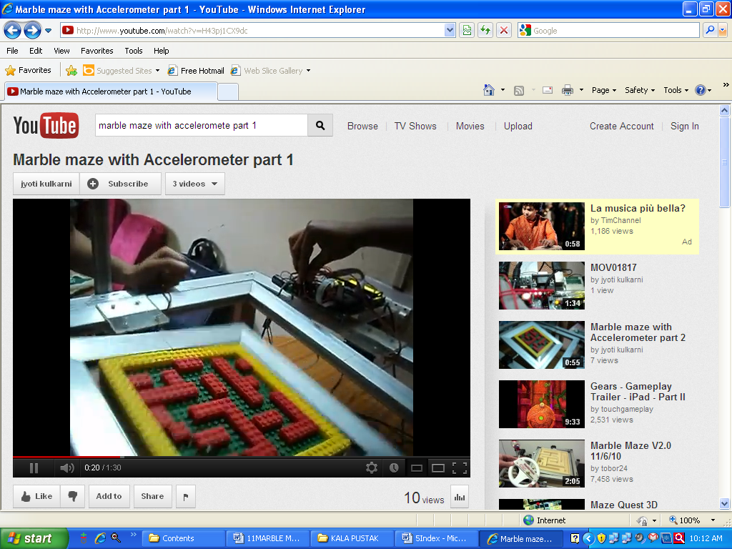

CHAPTER 6
ACKNOWLEDGEMENT

We are immensely obliged to present the final project report. We would like to take this opportunity to acknowledge the innumerable guidance and support extended by professors of Indian Institute of Technology, Bombay and our mentor
Mr. Pawankumar Suryawanshi. Also Mr. Piyush Manvar & Mr. Saurav Shandilya for their technical assistance and support. Also we would like to thank them for providing us various facilities required for our project.

We would like to give our sincere thank our H.O.D [Computer Engineering Department, K.G.C.E., Karjat] and Project Guide, Mr. Anup Kunte Sir for his encouragement, support and co-operation in development of this project.

We are also thankful to our co-guide Mrs. Anjali Mulwani for her kind support.

-------------------------------------------GHARAT APURVA ---------------------------------------------------------------------------------KULKARNI JYOTI ----------------------------------------------------------------------------------PATIL SUPRIYA ------------------------------------------

